Table of Contents

ER Diagram from Stage 2 2

Implementation: 3

-- Table: Customer 3

/* Values for table: Customer. */ 3

-- Table: Department 4

-- Values for table: Department 4

-- Table: Employee 5

-- Values for table: Employee 5

-- Table: Invoice 7

-- Values for table: Invoice 7

-- Table: Brand 8

-- Values of table: Brand 8

-- Table: Product 9

-- Values for table: Product 9

-- Table: Inv_Product 10

-- Values for table: Inv_Product 10

-- Table: Vendor 11

-- Values for table: Vendor 11

-- Table: Prod_Ven 12

-- Values for table: Prod_Ven 12

Stage 3: Questions: 13

References: 23

# ER Diagram from Stage 2



# Implementation:

## -- Table: Customer

CREATE TABLE CUSTOMER (

CUS_CODE VARCHAR(10) PRIMARY KEY,

CUS_FNAME VARCHAR(15),

CUS_LNAME VARCHAR(10),

CUS_STREET_NO NUMERIC(4),

CUS_STREET_NAME VARCHAR(15),

CUS_CITY VARCHAR(10),

CUS_STATE CHAR(2),

CUS_ZIP CHAR(4),

CUS_BALANCE INTEGER

);

### /* Values for table: Customer. */

INSERT INTO CUSTOMER VALUES('1001', 'Royal', 'Roy', '1', 'Warialda', 'Kogarah', 'Ns', '2217', '2000');

INSERT INTO CUSTOMER VALUES('1002', 'Koyal', 'Soy', '2', 'Houston', 'Texas', 'Qs', '2033', '9319');

INSERT INTO CUSTOMER VALUES('1003', 'Aoyal', 'Aoy', '3', 'Kensing', 'hillstay', 'Sy', '2034', '1302');

INSERT INTO CUSTOMER VALUES('1004', 'Boyal', 'Boy', '4', 'Burwood', 'Killstay', 'Ms', '2035', '3403');

INSERT INTO CUSTOMER VALUES('1005', 'Coyal', 'Coy', '5', 'Kenwood', 'Kenstay', 'NC', '2036', '2054');

INSERT INTO CUSTOMER VALUES('1006', 'Doyal', 'Doy', '6', 'Benwood', 'Senstay', 'Ml', '2037', '8045');

INSERT INTO CUSTOMER VALUES('1007', 'Eoyal', 'Eoy', '7', 'Boowood', 'Dicstay', 'Ad', '2038', '5233');

INSERT INTO CUSTOMER VALUES('1008', 'Foyal', 'Foy', '8', 'Botwood', 'Homstay', 'Ts', '2039', '2302');

INSERT INTO CUSTOMER VALUES('1009', 'Goyal', 'Goy', '9', 'Butwood', 'Sunstay', 'Dr', '2040', '4438');

INSERT INTO CUSTOMER VALUES('1010', 'Hoyal', 'Hoy', '10', 'Denwood', 'flostay', 'Pe', '2041', '4509');

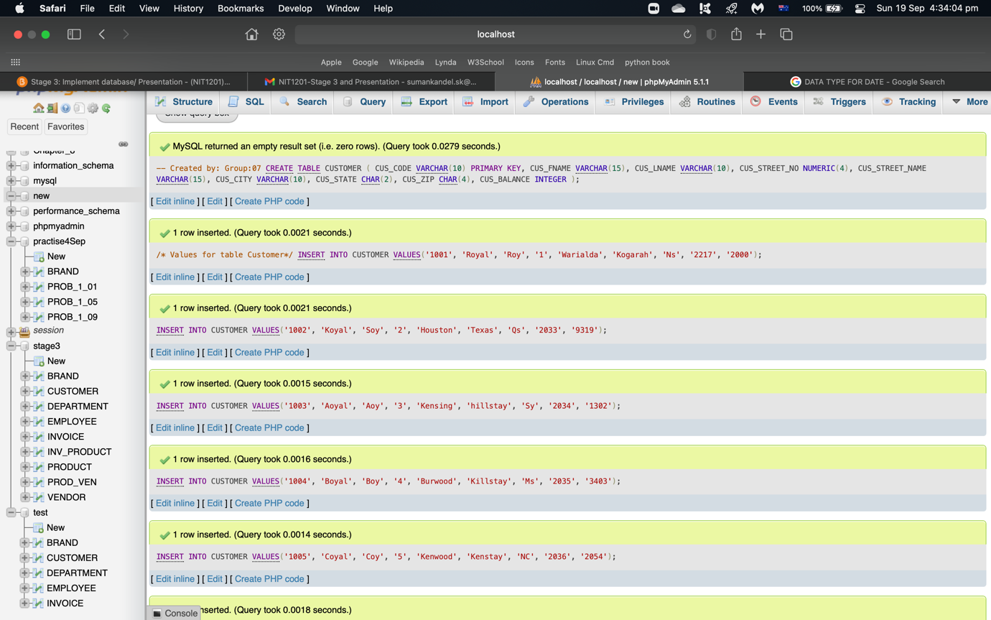

## -- Table: Department

CREATE TABLE DEPARTMENT(

DEPT_NUM INTEGER PRIMARY KEY,

DEPT_NAME VARCHAR(15),

DEPT_ADDRESS VARCHAR(20),

DEPT_PHONE VARCHAR(10)

);

### -- Values for table: Department

INSERT INTO DEPARTMENT VALUES ('121', 'Database', 'Grantham Farm', '02962348');

INSERT INTO DEPARTMENT VALUES ('122', 'Batabase', 'Abantham Farm', '02962349');

INSERT INTO DEPARTMENT VALUES ('123', 'Catabase', 'Cdantham Farm', '02962350');

INSERT INTO DEPARTMENT VALUES ('124', 'Eatabase', 'Efantham Farm', '02962351');

INSERT INTO DEPARTMENT VALUES ('125', 'Fatabase', 'Ghantham Farm', '02962352');

INSERT INTO DEPARTMENT VALUES ('126', 'Gatabase', 'Ijantham Farm', '02962353');

INSERT INTO DEPARTMENT VALUES ('127', 'Hatabase', 'Klantham Farm', '02962354');

INSERT INTO DEPARTMENT VALUES ('128', 'Iatabase', 'Mnantham Farm', '02962355');

INSERT INTO DEPARTMENT VALUES ('129', 'Jatabase', 'Opantham Farm', '02962356');

INSERT INTO DEPARTMENT VALUES ('130', 'katabase', 'Qrantham Farm', '02962357');

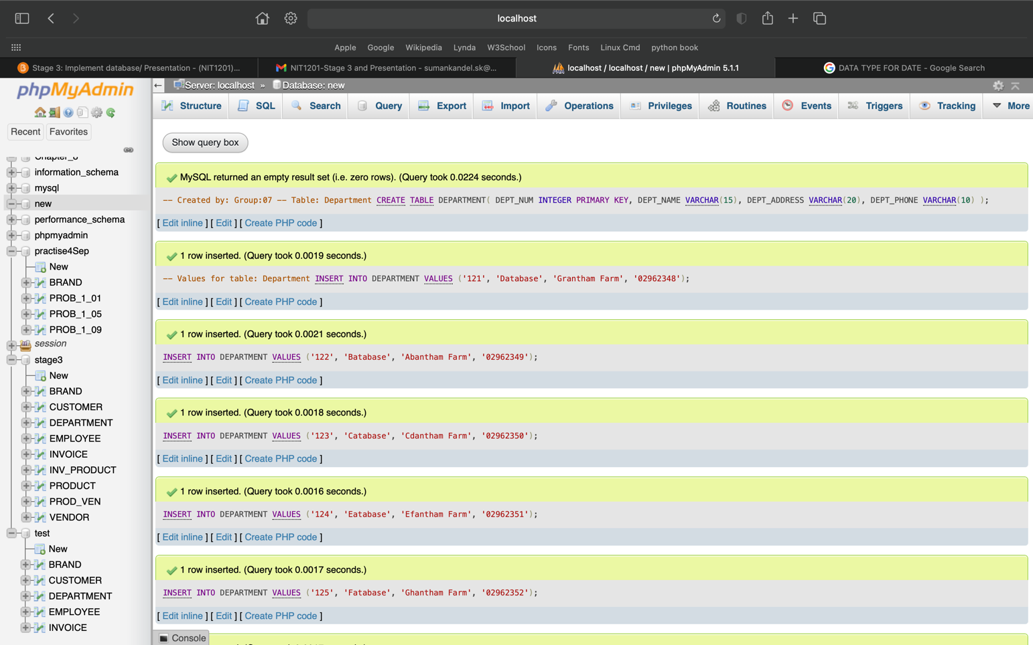

## -- Table: Employee

CREATE TABLE EMPLOYEE(

EMP_NUM INTEGER PRIMARY KEY,

EMP_FNAME VARCHAR(15),

EMP_LNAME VARCHAR(15),

EMP_EMAIL VARCHAR(15),

EMP_PHONE VARCHAR(10),

EMP_HIREDATE DATE,

EMP_SAL_FROM DATE,

EMP_SAL_END DATE,

EMP_SAL_AMOUNT INTEGER,

EMP_TITLE VARCHAR(10),

EMP_COMMISSION NUMERIC(8,2),

DEPT_NUM INTEGER,

FOREIGN KEY (DEPT_NUM) REFERENCES DEPARTMENT(DEPT_NUM)

);

### -- Values for table: Employee

INSERT INTO EMPLOYEE VALUES ('4001', 'Suman', 'Kandel','sm.kdl@mail.com','1111111111','2020-02-12','2020-02-20','2021-03-20','99675','Assistant', '2689.68','121' );

INSERT INTO EMPLOYEE VALUES ('4002', 'Auman', 'Aandel','Ab.kdl@mail.com','1111111112','2015-01-09','2015-01-12','2016-01-12','53845','Assistant', '2689.69','122' );

INSERT INTO EMPLOYEE VALUES ('4003', 'Buman', 'Bandel','Cd.kdl@mail.com','1111111113','2016-01-21','2016-01-29','2017-01-15','83731','Assistant', '2689.70','123' );

INSERT INTO EMPLOYEE VALUES ('4004', 'Cuman', 'Candel','Ef.kdl@mail.com','1111111114','2017-01-11','2017-01-20','2018-01-21','83745','Mr', '2689.71','124' );

INSERT INTO EMPLOYEE VALUES ('4005', 'Duman', 'Dandel','Gh.kdl@mail.com','1111111115','2018-01-02','2018-01-12','2019-01-29','99675','Mrs', '2689.72','123' );

INSERT INTO EMPLOYEE VALUES ('4006', 'Euman', 'Eandel','Ij.kdl@mail.com','1111111116','2020-12-31','2020-01-06','2021-08-24','83745','Dr', '2689.73','126' );

INSERT INTO EMPLOYEE VALUES ('4007', 'Fuman', 'Fandel','Kl.kdl@mail.com','1111111117','2021-01-23','2021-01-30','2021-01-08','44035','Miss', '2689.74','127' );

INSERT INTO EMPLOYEE VALUES ('4008', 'Guman', 'Gandel','Mn.kdl@mail.com','1111111118','2014-01-22','2014-01-12','2016-01-19','53845','Mr', '2689.75','128' );

INSERT INTO EMPLOYEE VALUES ('4009', 'Human', 'Handel','Op.kdl@mail.com','1111111119','2013-01-12','2013-01-22','2015-01-22','83745','Miss', '2689.76','123' );

INSERT INTO EMPLOYEE VALUES ('4010', 'Iuman', 'Iandel','Qr.kdl@mail.com','1111111120','2013-12-28','2014-02-26','2015-01-12','44035','Assistant', '2689.77','130' );

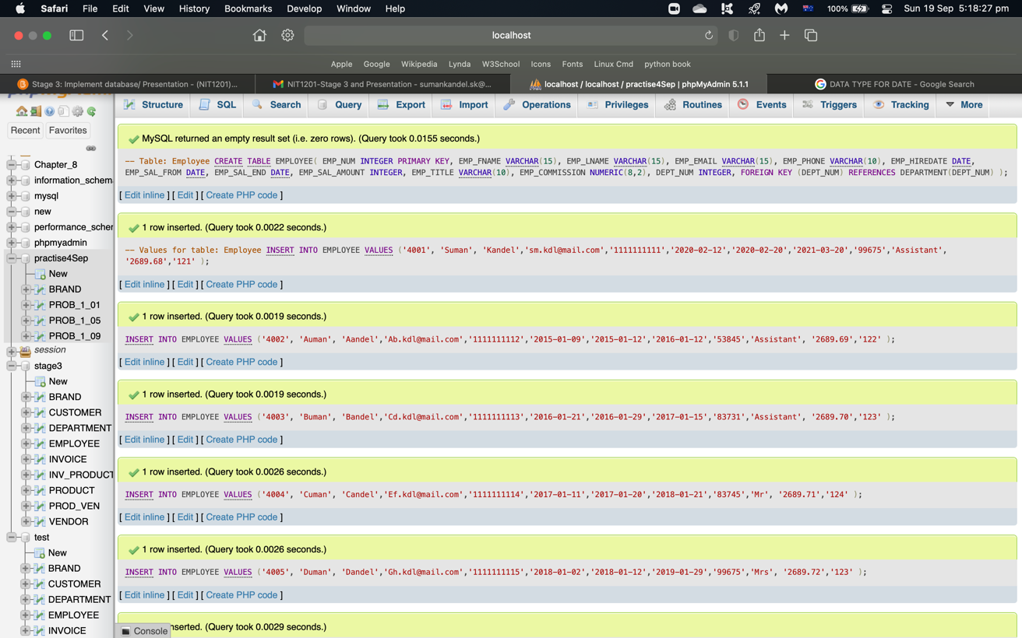

## -- Table: Invoice

CREATE TABLE INVOICE (

INV_NUM VARCHAR(10) PRIMARY KEY,

CUS_CODE VARCHAR(10),

EMP_NUM INTEGER,

INV_DATE DATE,

INV_TOTAL NUMERIC(8,2),

FOREIGN KEY (CUS_CODE ) REFERENCES CUSTOMER (CUS_CODE),

FOREIGN KEY (EMP_NUM) REFERENCES EMPLOYEE (EMP_NUM)

);

### -- Values for table: Invoice

INSERT INTO INVOICE VALUES( '100', '1001', '4001', '2008-10-01', '9050.22');

INSERT INTO INVOICE VALUES( '101', '1002', '4002', '2015-07-19', '3051.43');

INSERT INTO INVOICE VALUES( '102', '1003', '4003', '2021-05-10', '4051.76');

INSERT INTO INVOICE VALUES( '103', '1004', '4004', '2012-09-21', '7040.34');

INSERT INTO INVOICE VALUES( '104', '1005', '4005', '2011-04-13', '2090.32');

INSERT INTO INVOICE VALUES( '105', '1006', '4006', '2015-07-16', '6088.23');

INSERT INTO INVOICE VALUES( '106', '1007', '4007', '2019-03-17', '1123.55');

INSERT INTO INVOICE VALUES( '107', '1008', '4008', '2016-09-24', '4130.76');

INSERT INTO INVOICE VALUES( '108', '1009', '4009', '2015-07-16', '6032.34');

INSERT INTO INVOICE VALUES( '109', '1010', '4010', '2015-07-18', '3023.53');

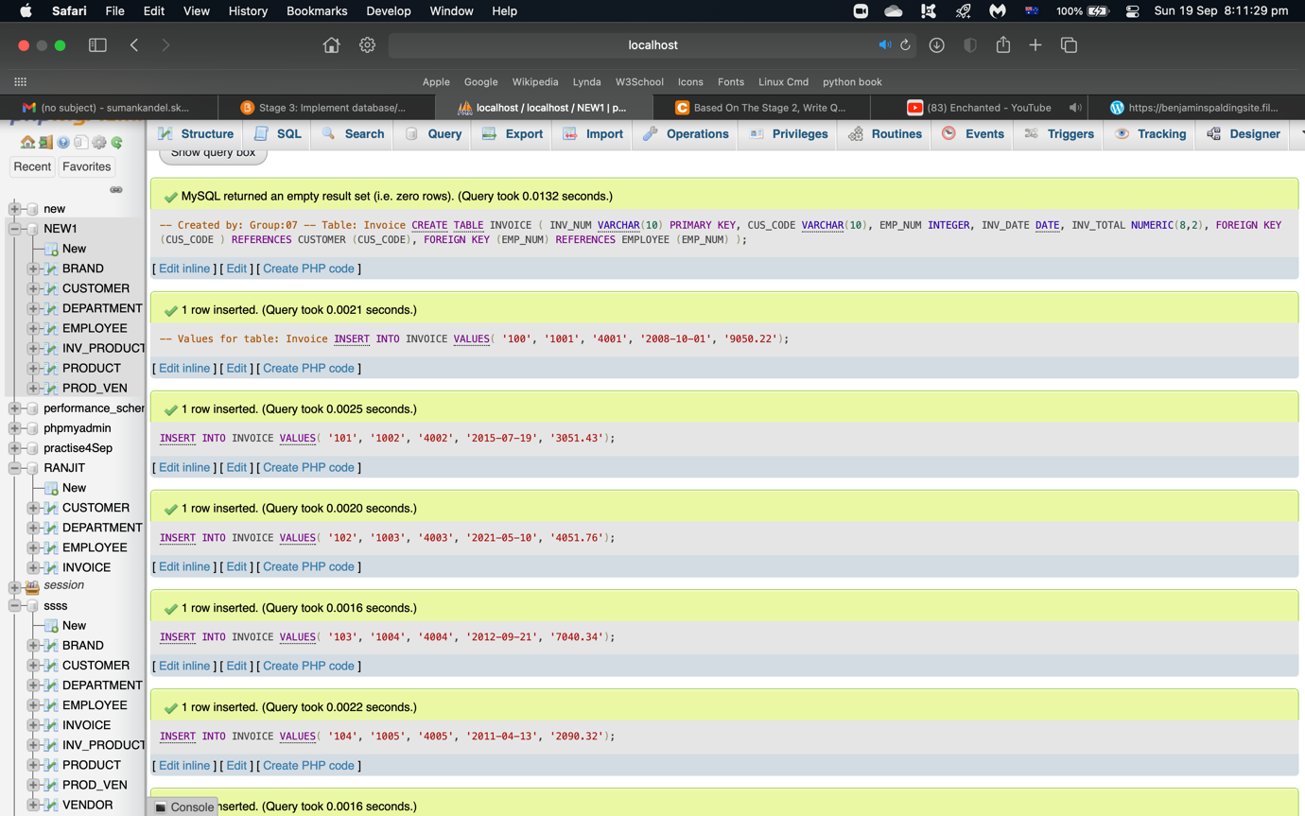

## -- Table: Brand

CREATE TABLE BRAND(

BRAND_ID INTEGER PRIMARY KEY,

BRAND_NAME VARCHAR(15),

BRAND_TYPE VARCHAR(25)

);

### -- Values of table: Brand

INSERT INTO BRAND VALUES ('800', 'noop', 'Information Technology');

INSERT INTO BRAND VALUES ('801', 'forest', 'Abformation Technology');

INSERT INTO BRAND VALUES ('802', 'forest', 'Cdformation Technology');

INSERT INTO BRAND VALUES ('803', 'CK', 'Efformation Technology');

INSERT INTO BRAND VALUES ('804', 'DK', 'Ghformation Technology');

INSERT INTO BRAND VALUES ('805', 'forest', 'IJformation Technology');

INSERT INTO BRAND VALUES ('806', 'FK', 'Klformation Technology');

INSERT INTO BRAND VALUES ('807', 'GK', 'Mnformation Technology');

INSERT INTO BRAND VALUES ('808', 'forest', 'Opformation Technology');

INSERT INTO BRAND VALUES ('809', 'forest', 'Qrformation Technology');

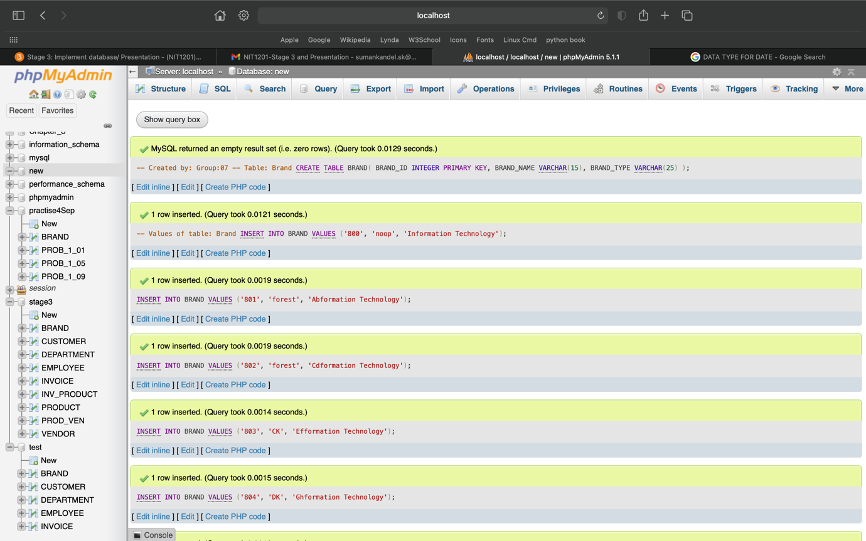

## -- Table: Product

CREATE TABLE PRODUCT(

PRODUCT_ID INTEGER PRIMARY KEY,

PRODUCT_DESCRIPTION VARCHAR(35),

PROD_TYPE VARCHAR(15),

PROD_BASE VARCHAR(15),

PROD_CATEGORY VARCHAR(35),

PROD_PRICE NUMERIC(8,2),

PROD_QTY_ONHAND INTEGER,

BRAND_ID INTEGER,

FOREIGN KEY(BRAND_ID) REFERENCES BRAND(BRAND_ID)

);

### -- Values for table: Product

INSERT INTO PRODUCT VALUES ('3331', 'Iphone 13', 'Apple', 'US', 'Iphone', '1999.99', '40', '800');

INSERT INTO PRODUCT VALUES ('3332', 'Bphone 14', 'Bople', 'water', 'sealer', '2000.01', '41', '801');

INSERT INTO PRODUCT VALUES('3333', 'Cphone 15', 'Cople', 'BS', 'Cphone', '2000.02', '42', '802');

INSERT INTO PRODUCT VALUES('3334', 'Dphone 16', 'Dople', 'CS', 'sealer', '2000.03', '43', '803');

INSERT INTO PRODUCT VALUES('3335', 'Ephone 17', 'Eople', 'water', 'Ephone', '2000.04', '44', '804');

INSERT INTO PRODUCT VALUES('3336', 'Fphone 18', 'Fople', 'water', 'sealer', '2000.05', '45', '805');

INSERT INTO PRODUCT VALUES('3337', 'Gphone 19', 'Gople', 'FS', 'Gphone', '2000.06', '46', '806');

INSERT INTO PRODUCT VALUES('3338', 'Hphone 20', 'Hople', 'water', 'Hphone', '2000.07', '47', '807');

INSERT INTO PRODUCT VALUES('3339', 'Jphone 21', 'Jople', 'HS', 'sealer', '2000.08', '48', '808');

INSERT INTO PRODUCT VALUES('3340', 'Kphone 22', 'Kople', 'water', 'Kphone', '2000.09', '49', '809');

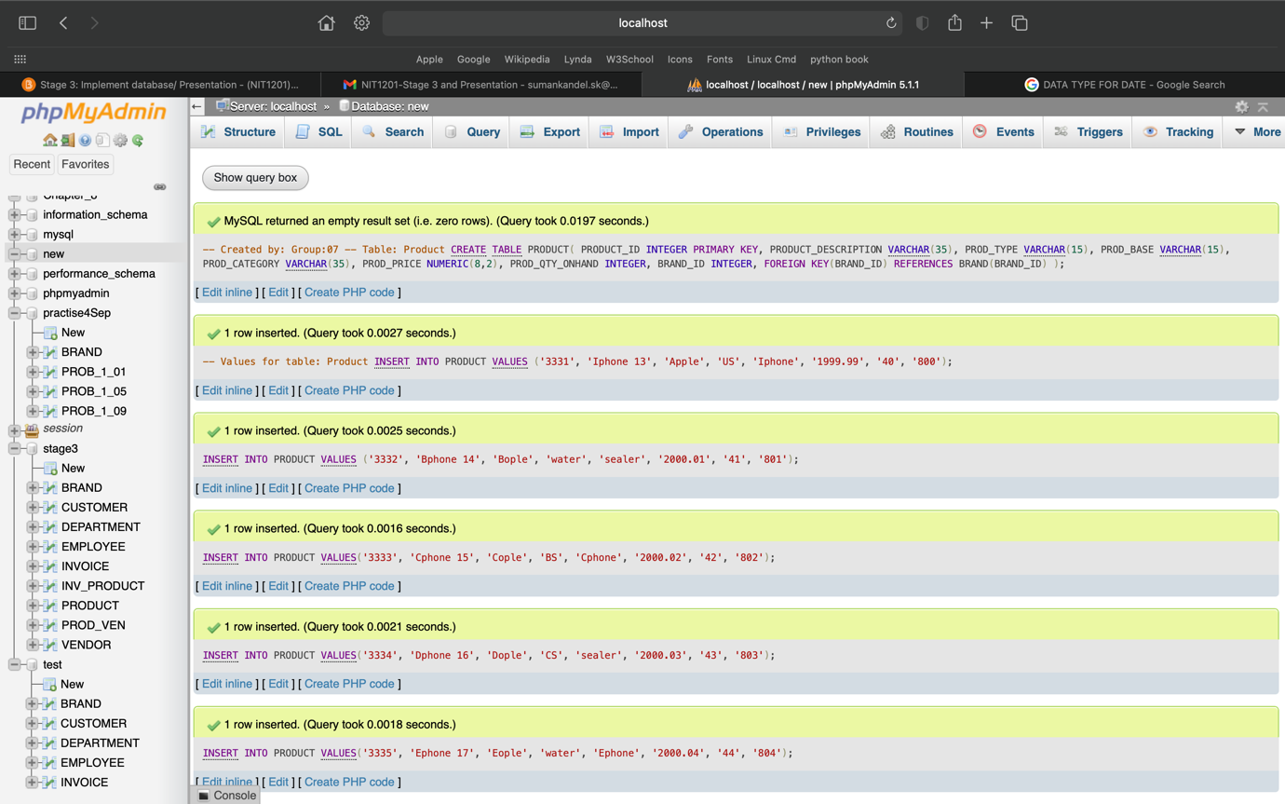

## -- Table: Inv_Product

CREATE TABLE INV_PRODUCT (

INV_NUM VARCHAR(10),

PRODUCT_ID INTEGER,

PRIMARY KEY (INV_NUM, PRODUCT_ID),

FOREIGN KEY (INV_NUM) REFERENCES INVOICE(INV_NUM),

FOREIGN KEY (PRODUCT_ID) REFERENCES PRODUCT(PRODUCT_ID)

);

### -- Values for table: Inv_Product

INSERT INTO INV_PRODUCT VALUES ('100', '3331');

INSERT INTO INV_PRODUCT VALUES ('101', '3332');

INSERT INTO INV_PRODUCT VALUES ('102', '3333');

INSERT INTO INV_PRODUCT VALUES ('103', '3334');

INSERT INTO INV_PRODUCT VALUES ('104', '3335');

INSERT INTO INV_PRODUCT VALUES ('105', '3336');

INSERT INTO INV_PRODUCT VALUES ('106', '3337');

INSERT INTO INV_PRODUCT VALUES ('107', '3338');

INSERT INTO INV_PRODUCT VALUES ('108', '3339');

INSERT INTO INV_PRODUCT VALUES ('109', '3340');

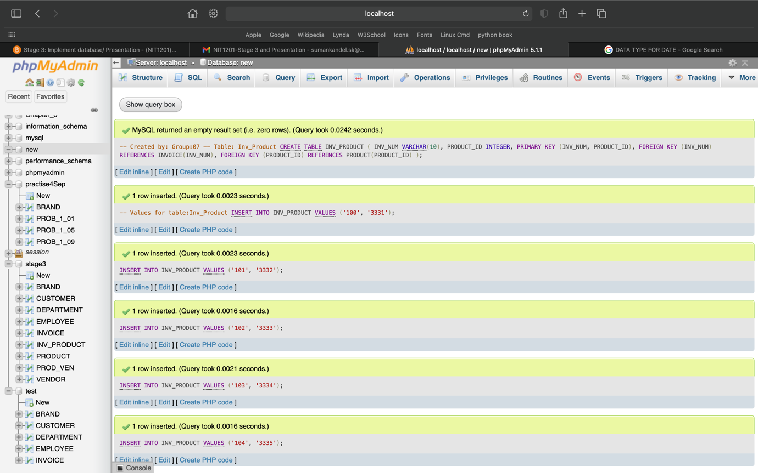

## -- Table: Vendor

CREATE TABLE VENDOR(

VEND_ID INTEGER PRIMARY KEY,

VEND_NAME CHAR(10),

VEND_STREET_NO CHAR(3),

VEND_STREET_NAME VARCHAR(35),

VEND_CITY CHAR(10),

VEND_STATE CHAR(3)

);

### -- Values for table: Vendor

INSERT INTO VENDOR VALUES ('7001','Grantham','RVR', 'Willam Street', 'Riverstone', 'NSW');

INSERT INTO VENDOR VALUES ('7002', 'Abantham','AVR', 'Aillam Street', 'Aiverstone', 'ASW');

INSERT INTO VENDOR VALUES ('7003', 'Cdantham','BVR', 'Billam Street', 'Biverstone', 'BSW');

INSERT INTO VENDOR VALUES ('7004', 'Efantham','CVR', 'Cillam Street', 'Civerstone', 'CSW');

INSERT INTO VENDOR VALUES ('7005', 'Ghantham','DVR', 'Dillam Street', 'Diverstone', 'DSW');

INSERT INTO VENDOR VALUES ('7006', 'Ijantham','EVR', 'Eillam Street', 'Eiverstone', 'ESW');

INSERT INTO VENDOR VALUES ('7007', 'Klantham','FVR', 'Fillam Street', 'Fiverstone', 'FSW');

INSERT INTO VENDOR VALUES ('7008', 'Mnantham','GVR', 'Gillam Street', 'Giverstone', 'GSW');

INSERT INTO VENDOR VALUES ('7009', 'Opantham','HVR', 'Hillam Street', 'Hiverstone', 'HSW');

INSERT INTO VENDOR VALUES ('7010', 'Qrantham','JVR', 'Jillam Street', 'Jiverstone', 'JSW');

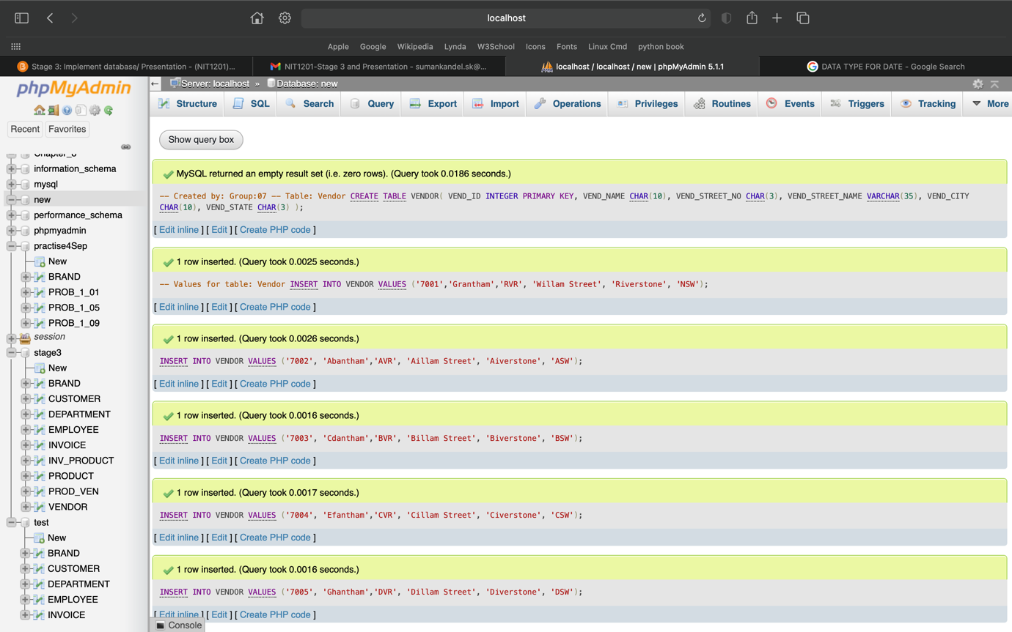

## -- Table: Prod_Ven

CREATE TABLE PROD_VEN(

VEND_ID INTEGER,

PRODUCT_ID INTEGER,

PRIMARY KEY (VEND_ID, PRODUCT_ID),

FOREIGN KEY (VEND_ID) REFERENCES VENDOR(VEND_ID),

FOREIGN KEY (PRODUCT_ID) REFERENCES PRODUCT(PRODUCT_ID)

);

### -- Values for table: Prod_Ven

INSERT INTO PROD_VEN VALUES ('7001','3331');

INSERT INTO PROD_VEN VALUES ('7002','3332');

INSERT INTO PROD_VEN VALUES ('7003','3333');

INSERT INTO PROD_VEN VALUES ('7004','3334');

INSERT INTO PROD_VEN VALUES ('7005','3335');

INSERT INTO PROD_VEN VALUES ('7006','3336');

INSERT INTO PROD_VEN VALUES ('7007','3337');

INSERT INTO PROD_VEN VALUES ('7008','3338');

INSERT INTO PROD_VEN VALUES ('7009','3339');

INSERT INTO PROD_VEN VALUES ('7010','3340');

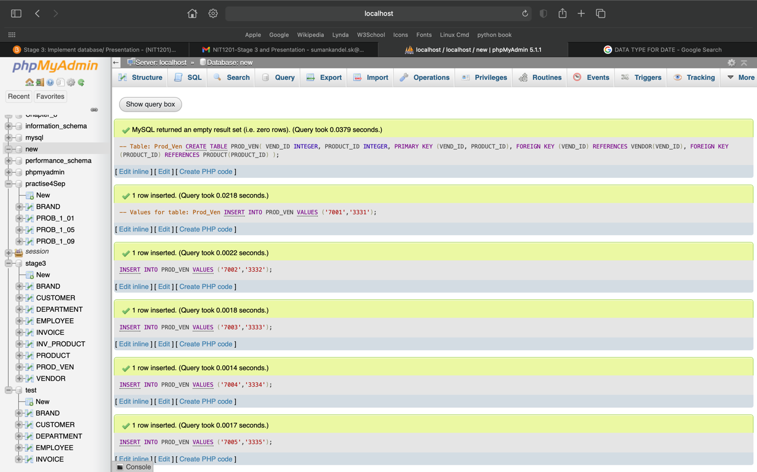

# Stage 3: Questions:

1. Write a query to display all vendors sorted by vendor name.

-- Query to display all vendors sorted by vendor name:

Select *

From Vendor

Order by Vend_NAME;

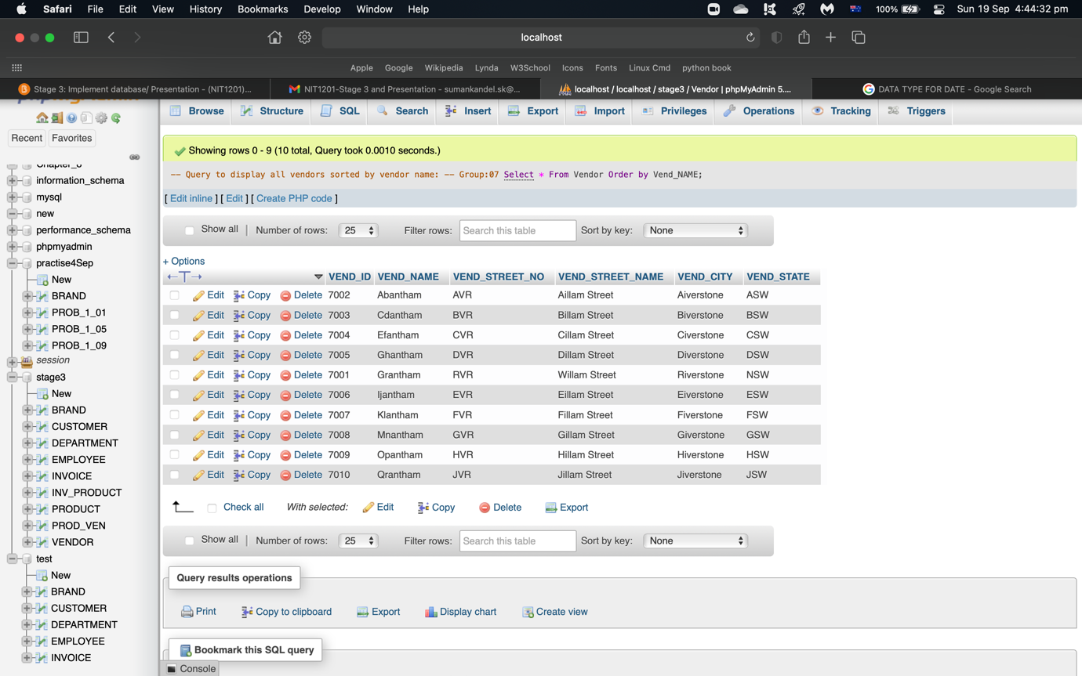

1. Write a query to display the product id, description, type, base, category, and price for all products that have a product base of **water**and a product category of sealer.

-- Created by: Group:07

SELECT PRODUCT_ID, PRODUCT_DESCRIPTION, PROD_TYPE, PROD_BASE, PROD_CATEGORY, PROD_PRICE

FROM PRODUCT

WHERE PROD_BASE = 'water' AND PROD_CATEGORY = 'sealer';

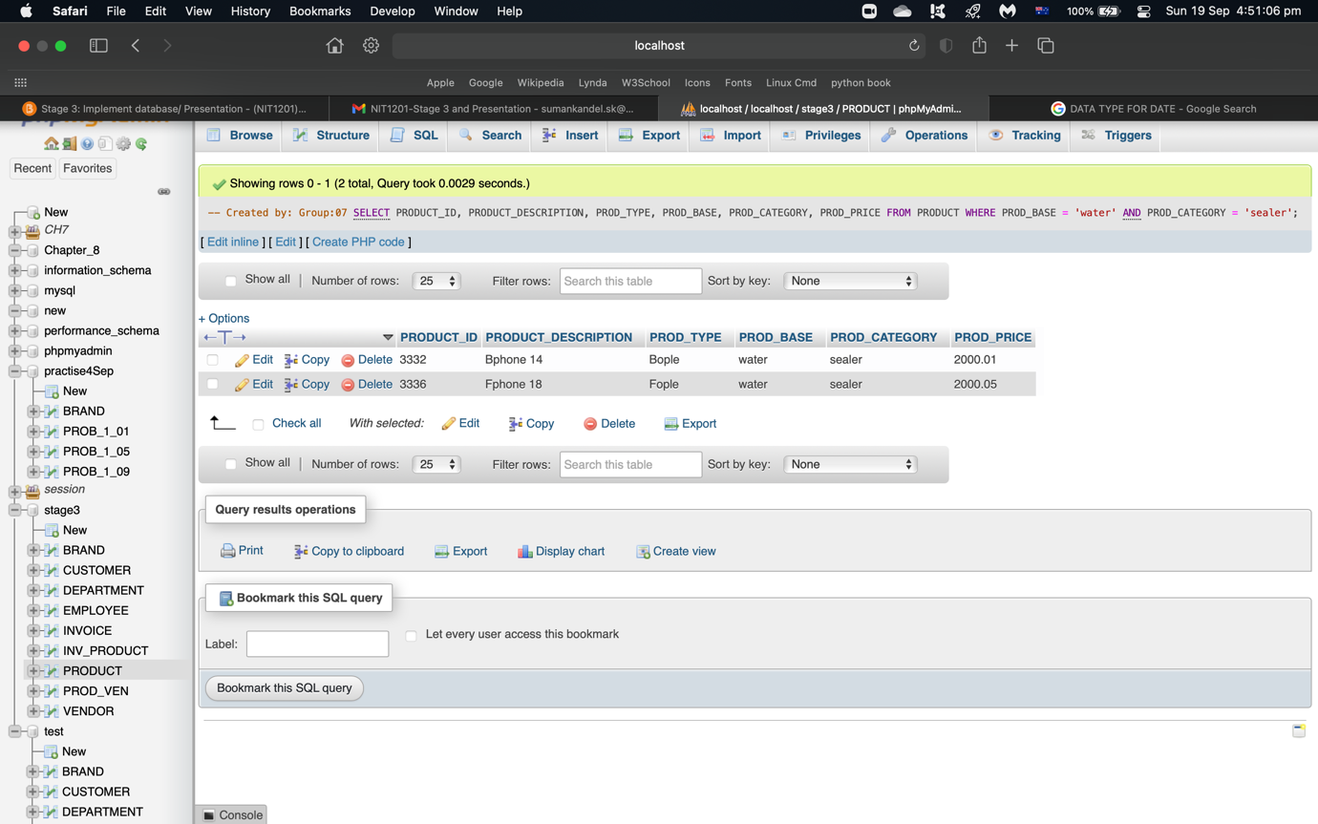

1. Write a query to display the first name, last name, and email address of employees who were not hired from January 1, 2015, to December 31, 2019. Sort the output by last name and then by first name.

-- Created by: Group:07

SELECT EMP_FNAME, EMP_LNAME, EMP_EMAIL

FROM EMPLOYEE

WHERE EMP_NUM NOT IN (SELECT EMP_NUM FROM EMPLOYEE WHERE EMP_HIREDATE BETWEEN '2015-01-01' AND '2019-12-31')

ORDER BY EMP_LNAME, EMP_FNAME;

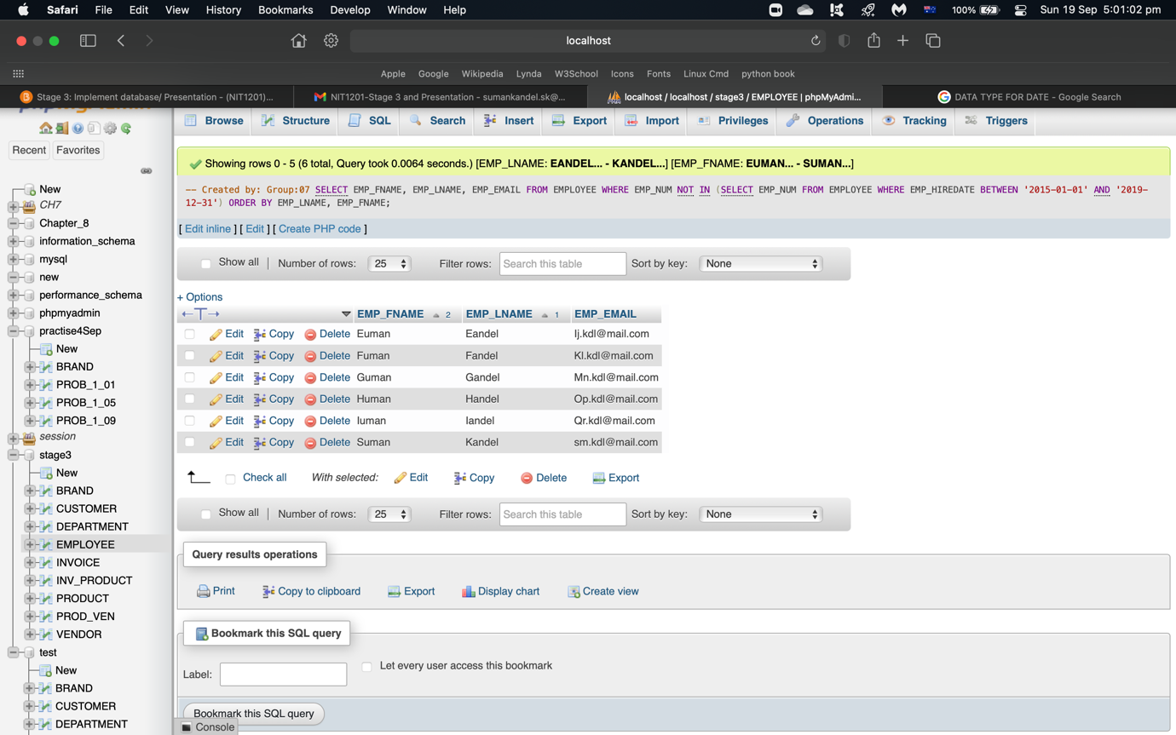

1. Write a query to display the first name, last name, phone number, title, and department number of employees who work in department 123 and have the title “Assistant.”

-- Created by: Group:07

SELECT EMP_FNAME, EMP_LNAME, EMP_PHONE, EMP_TITLE, DEPT_NUM

FROM EMPLOYEE

WHERE DEPT_NUM = '123' AND EMP_TITLE = 'Assistant';

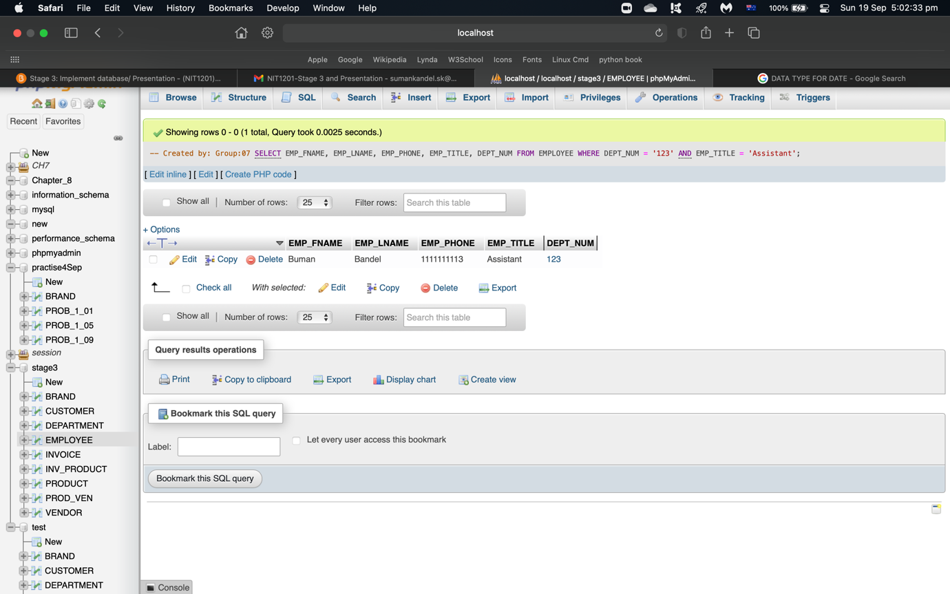

1. Write a query to display the employee number, last name, first name, salary “from” date, salary end date, and salary amount for employees 99675, 53845, and 44035. Sort the output by employee number and salary “from” date.

-- Created by: Group:07

SELECT EMP_NUM, EMP_LNAME, EMP_FNAME, EMP_SAL_FROM, EMP_SAL_END, EMP_SAL_AMOUNT

FROM EMPLOYEE

WHERE EMP_SAL_AMOUNT = '99675' OR EMP_SAL_AMOUNT= '53845' OR EMP_SAL_AMOUNT= '44035'

ORDER BY EMP_NUM, EMP_SAL_FROM;

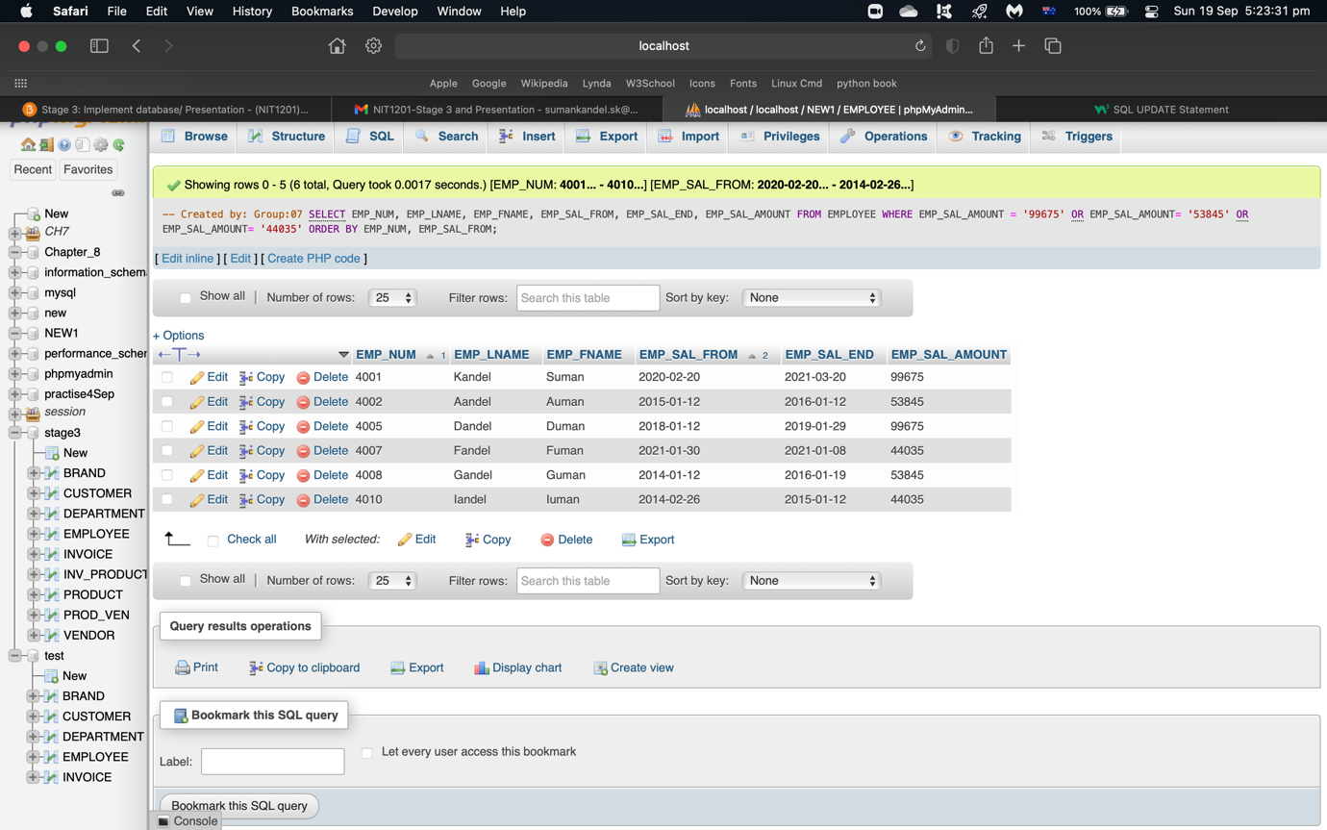

1. Write a query to display the first name, last name, street no, street name, city, state, and zip code of any customer who purchased a **Forest** brand between July 15, 2015, and Jul 20, 2015. If a customer purchased more than one such product, display the customer’s information only once in the output.

-- Created by: Group:07

SELECT CUS_FNAME, CUS_LNAME, CUS_STREET_NO, CUS_STREET_NAME, CUS_CITY, CUS_STATE, CUS_ZIP, BRAND_NAME

FROM CUSTOMER NATURAL JOIN INVOICE NATURAL JOIN INV_PRODUCT NATURAL JOIN PRODUCT NATURAL JOIN BRAND

WHERE BRAND_NAME = 'forest' AND (INV_DATE BETWEEN '2015-07-15' AND '2015-07-20');

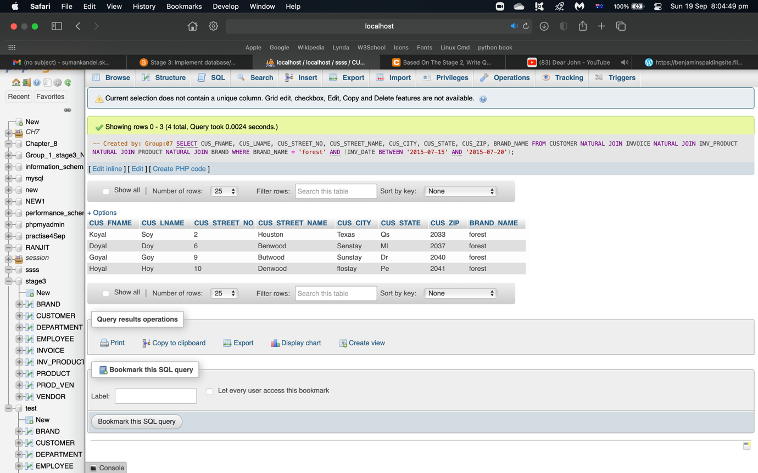

1. Write a query to display the employee number, last name, email address, title, and department name of each employee whose job title does **not**end in the word ”Assistant".

-- Created by: Group:07

SELECT EMP_NUM, EMP_LNAME, EMP_EMAIL, EMP_TITLE, DEPT_NAME

FROM EMPLOYEE NATURAL JOIN DEPARTMENT

WHERE EMP_TITLE NOT LIKE '%assistant';

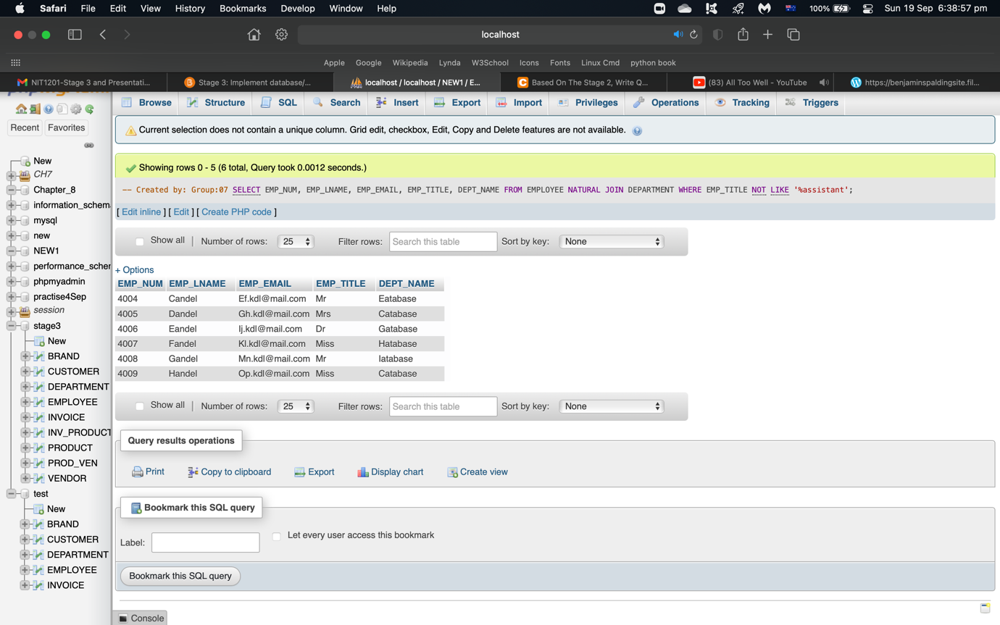

1. Write a query to display a brand name and the number of products of that brand that are in the database. Sort the output by the brand name.

-- Created by: Group:07

SELECT BRAND_TYPE, BRAND_NAME, COUNT(PRODUCT.BRAND_ID) AS COUNTS

FROM PRODUCT JOIN BRAND USING (BRAND_ID)

WHERE PRODUCT.BRAND_ID IN (SELECT BRAND_ID FROM BRAND)

GROUP BY BRAND_NAME, BRAND_TYPE

ORDER BY BRAND_NAME;

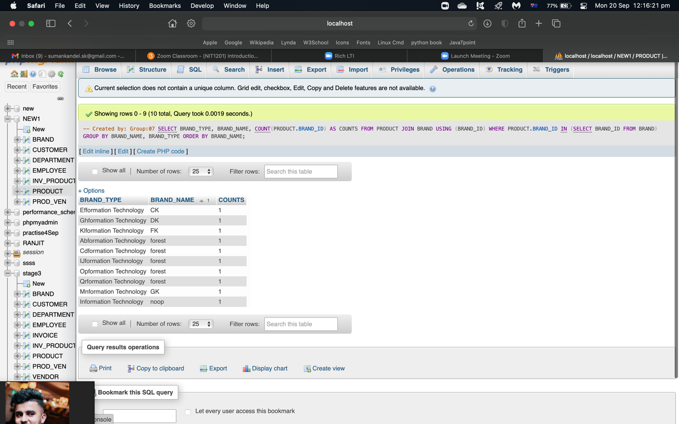

1. Write a query to display the number of products in each category that have a water base, sorted by category.

-- Created by: Group:07

SELECT PROD_CATEGORY, COUNT(BRAND_ID) as numproducts

FROM PRODUCT

WHERE PROD_BASE='Water'

GROUP BY PROD_CATEGORY

ORDER BY PROD_CATEGORY;

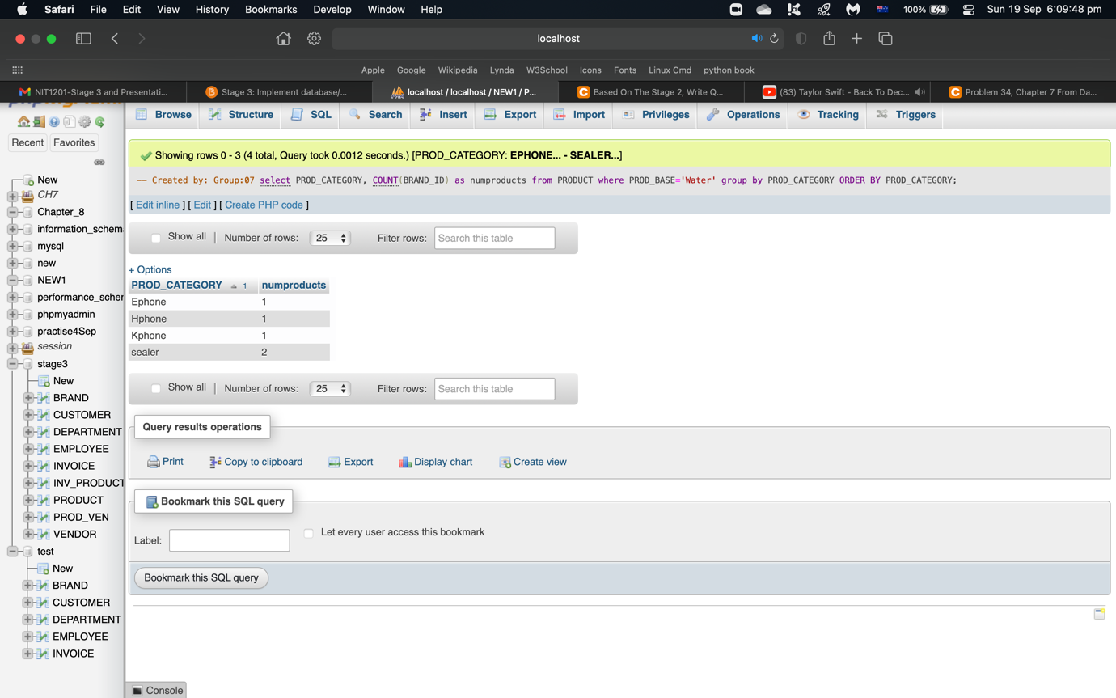

1. Write a query to display the total inventory, i.e. the sum of all products on hand for each brand id. Sort the output by brand id in ascending order.

SELECT SUM(PROD_QTY_ONHAND), BRAND_ID

FROM PRODUCT

GROUP BY BRAND_ID

ORDER BY BRAND_ID;

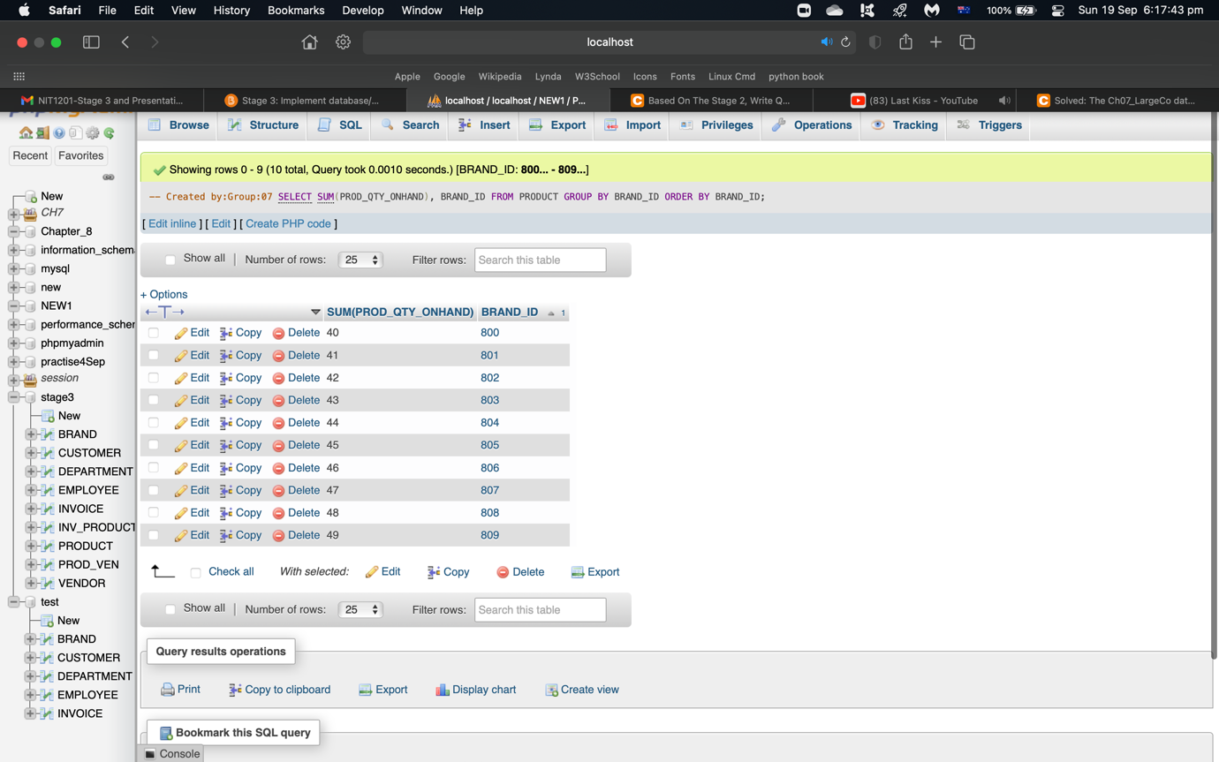

# References:

Learn to write basic SQL queries. (2020, March 27). SQL Shack - articles about database auditing, server performance, data recovery, and more. <https://www.sqlshack.com/learn-to-write-basic-sql-queries/>

More efficient SQL with query planning and optimization (article). (n.d.). Khan Academy. <https://www.khanacademy.org/computing/computer-programming/sql/relational-queries-in-sql/a/more-efficient-sql-with-query-planning-and-optimization>